## Diagonal Difference

Write a program that finds the **difference between** the **sums** of the **square matrix diagonals** (absolute value).

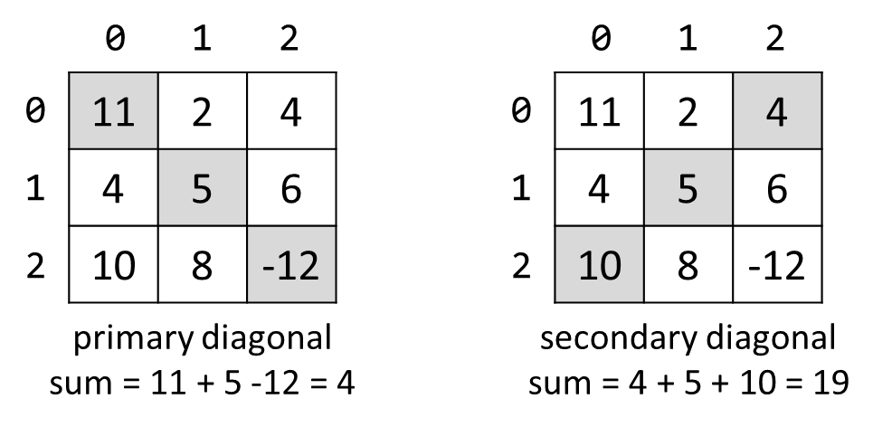

### Input

* On the **first line**, you are given the integer **N** - the size of the square matrix
* The next N **lines** holds the values for **every row** - N numbers separated by a space

### Output

* Print **the absolute** difference between **the sums** of the primary and the secondary diagonal

### Examples

|  |  |  |
| --- | --- | --- |
| **Input** | **Output** | **Comments** |
| 3  11 2 4  4 5 6  10 8 -12 | 15 | **Primary diagonal:** sum = 11 + 5 + (-12) = 4  **Secondary diagonal:** sum = 4 + 5 + 10 = 19  **Difference:** |4 - 19| = 15 |